**FlyAway (An Airline Booking Portal)**

**Projection Description:**

As a Full Stack Developer, design and develop an airline booking portal named as FlyAway. Use the GitHub repository to manage the project artifacts.

**Background of the problem statement:**

FlyAway is a ticket-booking portal that lets people book flights on their website.

**The website needs to have the following features:**

● A search form in the homepage to allow entry of travel details, like the date of travel, source, destination, and the number of persons.  
● Based on the travel details entered, it will show the available flights with their ticket prices.  
● Once a person selects a flight to book, they will be taken to a register page where they must fill in their personal details. In the next page, they are shown the flight details of the flight that they are booking, and the payment is done via a dummy payment gateway. On completion of the payment, they are shown a confirmation page with the details of the booking.   

For the above features to work, there will be an admin backend with the following features:

● An admin login page where the admin can change the password after login, if he wishes  
● A master list of places for source and destination  
● A master list of airlines  
● A list of flights where each flight has a source, destination, airline, and ticket price  
       
The goal of the company is to deliver a high-end quality product as early as possible. 

**Project Users Stories**

As a full stack developer, I want to develop airline online reservation portal with advanced java concepts to achieve below mentioned business functionality,

* As a user, I want airline website to book airline tickets.
* As a user, I want to login using login page and enter the welcome page.
* As a user, I want to search for flights available based on date, source & destination city.
* As a user, I want to select a flight and book the flight.
* As a user, I want to list and view the confirmed booking status.
* As a user, I want to logout of the portal.
* As a developer, I want to build login page to allow user to enter the user’s name and password with HTML page.
* As a developer, I want to create JSP to check user name and password are valid when use hits submit button.
* As a developer, I want to create JSP for welcome home page with hyperlinks for search flights, list confirmed flights and logoff.
* As a developer, I want to create JSP to get the user input for date of travel, source and destination city, total no of travelers and display the available flights based on the selection criteria.
* As a developer, I want to create JSP which allows to book the flight.
* As a developer, I want to collect user personal information and direct to payment confirmation page.
* As a developer, I want to create JSP to confirm and book the flight and show the confirmation message.
* As a developer, I want to create JSP for logout option.

**Sprint 1 (Week 1)**

* As a user, I want to select a flight and book the flight.
* As a user, I want to list and view the confirmed booking status.
* As a user, I want to logout of the portal.

As a developer, I want to build login page to allow user to enter the user’s name and password with HTML page.

* As a developer, I want to create JSP to check user name and password are valid when use hits submit button.
* As a developer, I want to create JSP for welcome home page with hyperlinks for search flights, list confirmed flights and logoff.

**Sprint 2 (Week 2)**

* As a developer, I want to create JSP to get the user input for date of travel, source and destination city, total no of travelers and display the available flights based on the selection criteria.
* As a developer, I want to create JSP which allows to book the flight.
* As a developer, I want to collect user personal information and direct to payment confirmation page.
* As a developer, I want to create JSP to confirm and book the flight and show the confirmation message.
* As a developer, I want to create JSP for logout option.

**Sprint 3 (Week 3)**

* Testing the Java program with different kinds of User input.
* Initializing git repository to track changes as development progresses.
* Pushing code to GitHub.
* Creating this specification document with application details, appearance, and user interactions.

## **Core Java concepts used in project**

* HTML web page creation,
* JSPS and JSTL program and configuration files,
* JDBC concepts for database table updation.

**Architecture diagram / flow chart:**

Create database tables and insert values into the tables.

Create JSP for welcome page for user login , account creation , password change.

Create JSP for home page with search flights , list booked flights and logoff

Create JSP for search flight page with search criteria needed to list available flights

Create JSP to list the available flights and book option.

Create JSP to collect personal information for flight booking.

Create JSP to review the information and collect payment details.

Create JSP to display the flight booking details , with an option to go back to home page and logoff.

**Database Table Creation**

CREATE TABLE userlogin (username varchar(50) NOT NULL,password varchar(128) NOT NULL,PRIMARY KEY (username));

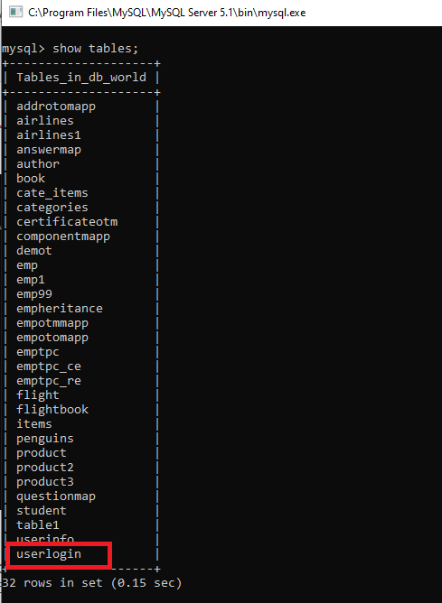

insert into userlogin values('Rohan@gmail.com','rohan123*');

insert into userlogin values(‘Mala@gmail.com’,’mala123*’);

insert into userlogin values(‘Kiran@gmail.com’,’kiran123*’);

insert into userlogin values(‘Raj@gmail.com’,’raj123*’);

insert into userlogin values(‘Ramya@gmail.com’,’ramya123*’);

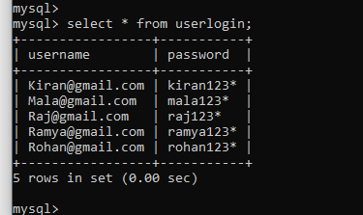

CREATE TABLE flight (flight_no varchar(50) NOT NULL,airline_name varchar(50) NOT NULL, price int NOT NULL, source_city varchar(50) NOT NULL, destination_city varchar(50) NOT NULL, departure_time TIME NOT NULL, arrival_time TIME NOT NULL, total_seats int NOT NULL, booked_seats int NOT NULL, seat_availibility int NOT NULL, date_of_travel varchar(50) NOT NULL, class varchar(50) NOT NULL , PRIMARY KEY (flight_no));

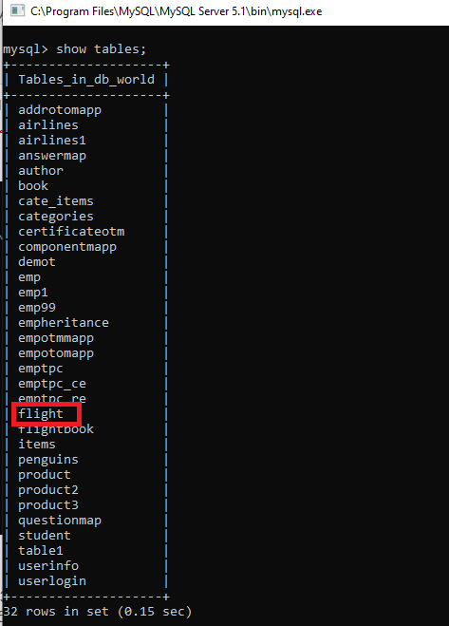

insert into flight values ("AA1234","American Express",15000,"New York","Chicago","10:50:00","15:50:00",150,70,80,'12/04/2021',"Economy");

insert into flight values ("AA1254","American Express",15000,"Washington","Chicago","10:50:00","15:50:00",150,70,80,'03/02/2021'," Business");

insert into flight values ("SW9234","South West",18000,"Florida","Chicago","10:50:00","15:50:00",150,70,80,'09/07/2021',"Business");

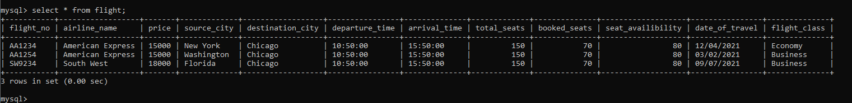

CREATE TABLE userinfo (User_Name varchar(50) NOT NULL, Full_Name varchar(50) NOT NULL, Address varchar(50) NOT NULL, Age int NOT NULL, mobile varchar(50) NOT NULL, Identity_card varchar(50) NOT NULL, country varchar(50) NOT NULL, PRIMARY KEY (User_Name));

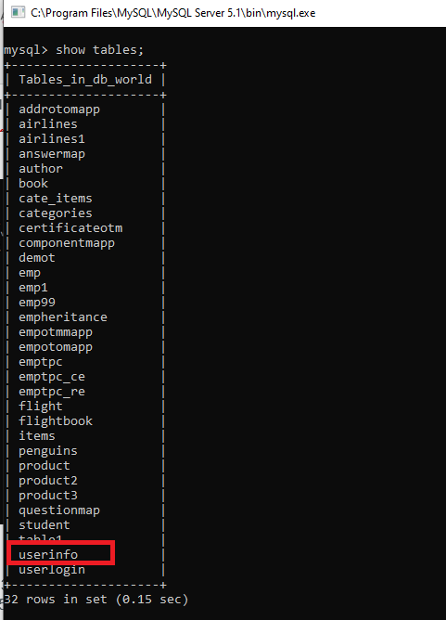

CREATE TABLE flightbook

(

id INT AUTO_INCREMENT PRIMARY KEY,

email_id VARCHAR(90) NOT NULL, flight_no VARCHAR(90) NOT NULL , source_city VARCHAR(90) NOT NULL, dest_city VARCHAR(90) NOT NULL, travel_date VARCHAR(90) NOT NULL, tot_passenger int NOT NULL , price float NOT NULL , flight_class VARCHAR(90) NOT NULL

)

AUTO_INCREMENT = 10011001;

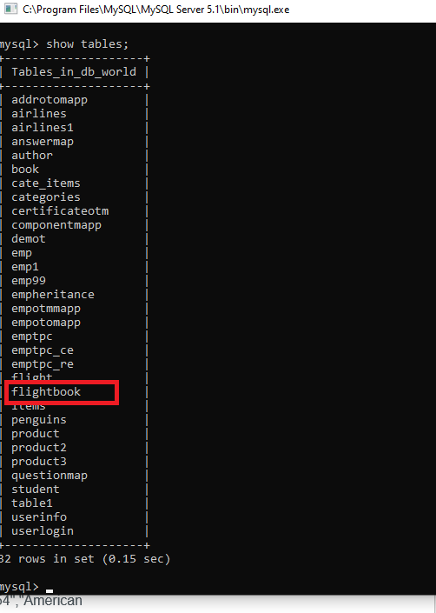

**Output Screenshots:**

* Open Eclipse and project folder.
* Go to Flyawaylogin.jsp Run -> Run on server.
* Login and welcome screen display as below,

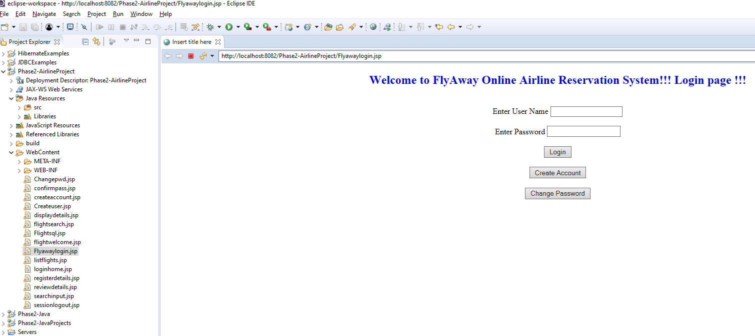

* Create account here, upon submit userlogin table gets updated.

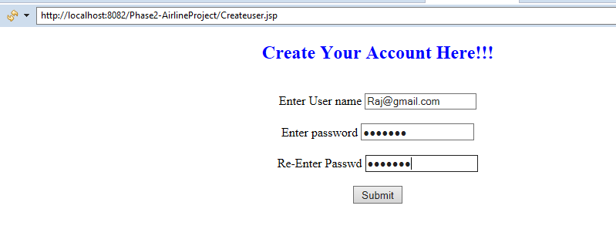

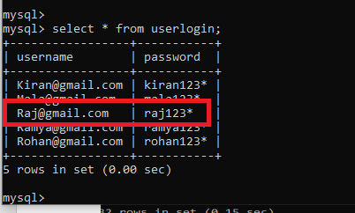

* Account Creation screen validations.

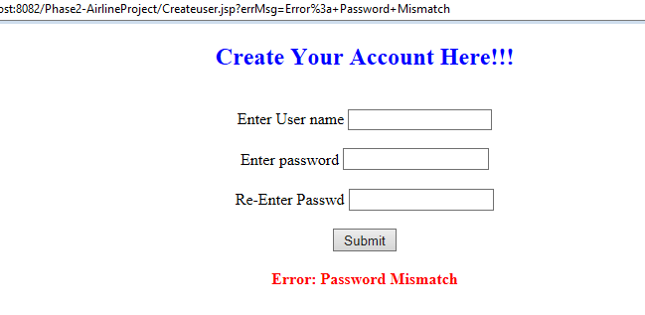

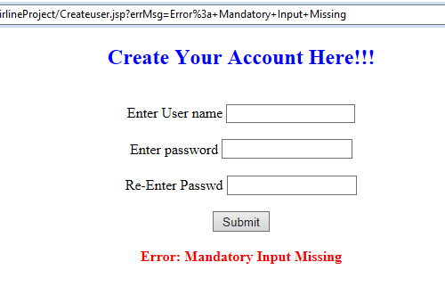

* Change password screen, upon submit password gets updated in the userlogin table.

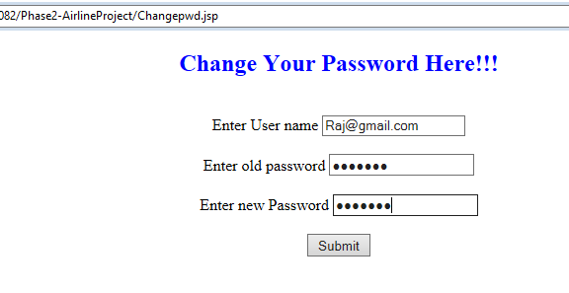

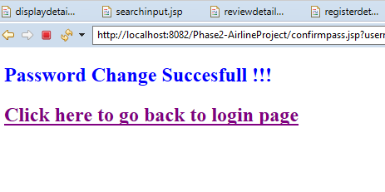

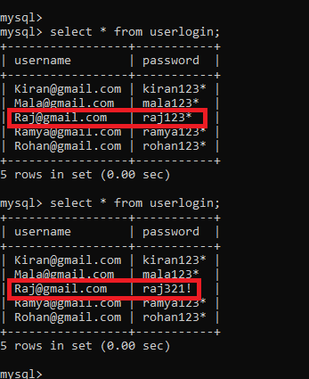

* Change password screen validations.

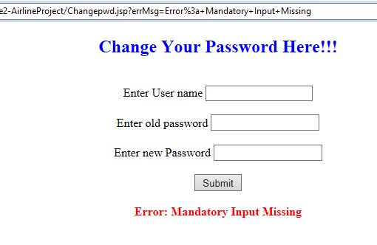

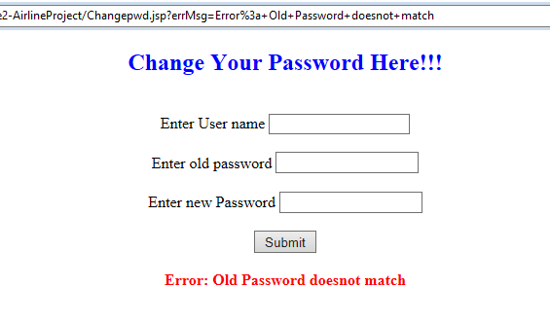

* Login screen validations.

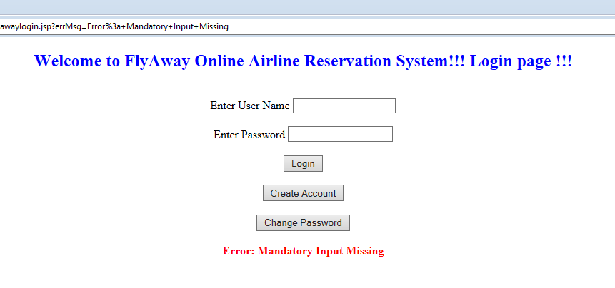

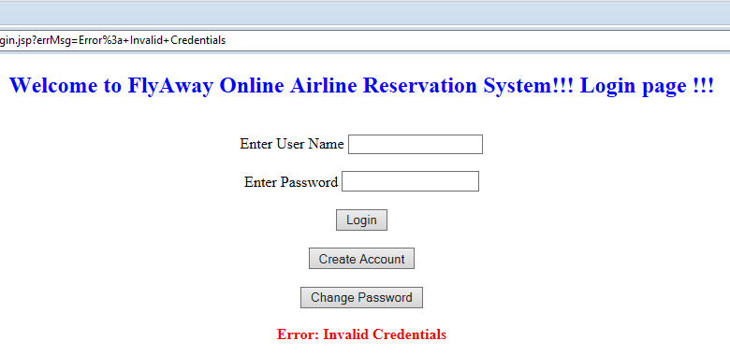

* Login screen validates username and password from the userlogin table values and upon login takes up to the welcome page.

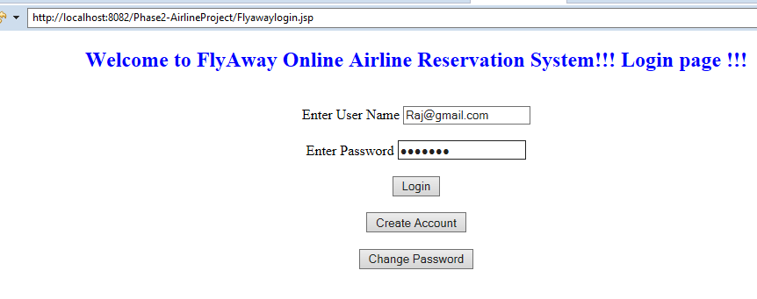

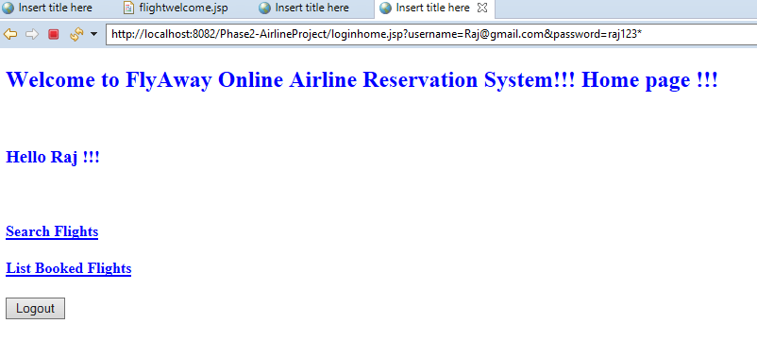

* Search flight selection criteria are collected from the user,

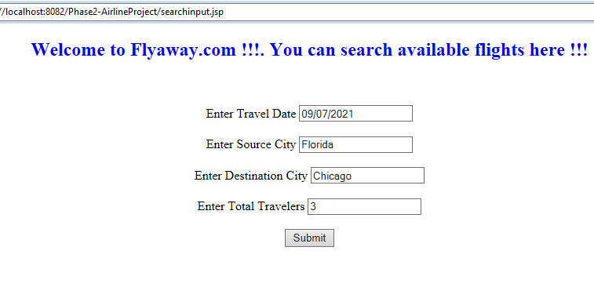

* Search flight table is done and displayed for booking,

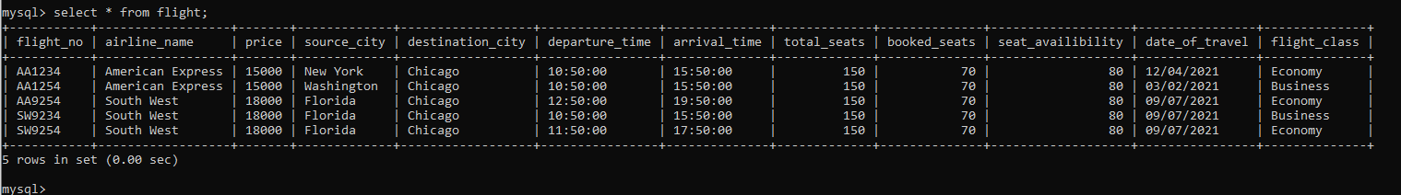

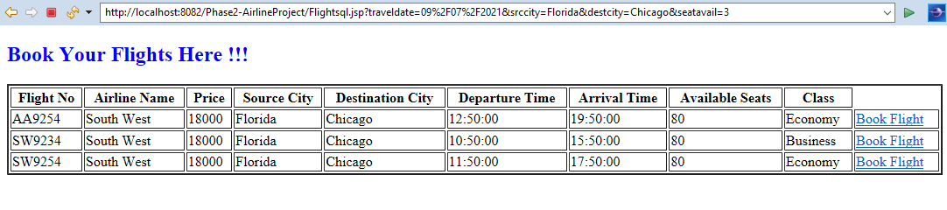

* Upon clicking book flights, Personal details are collected and userinfo table gets updated.

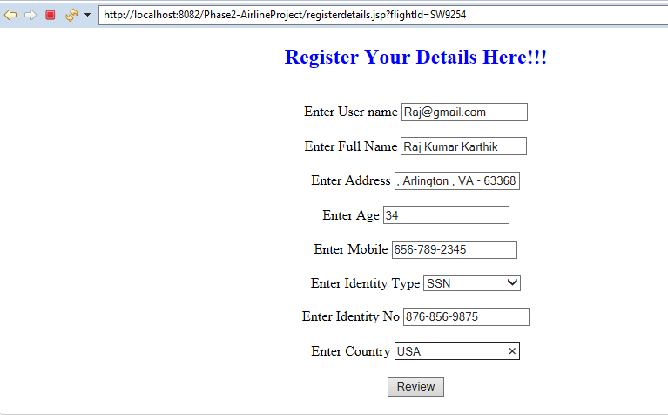

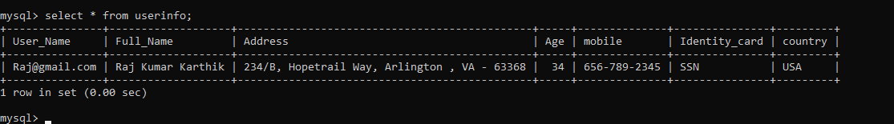

* Review the details and enter payment information and click on submit payment button.

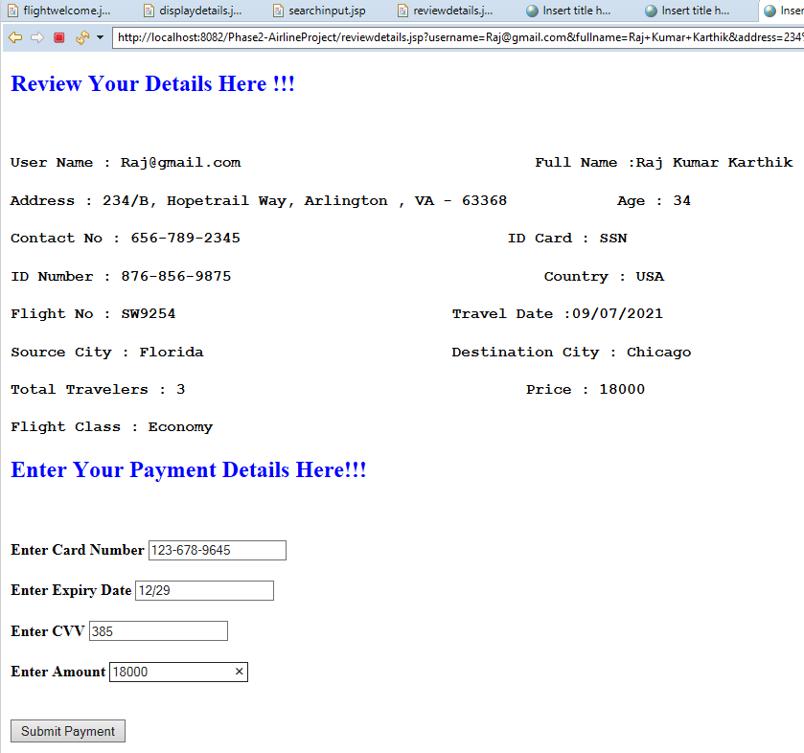

* Airline successful booking page gets displayed and flightbook table gets updated.

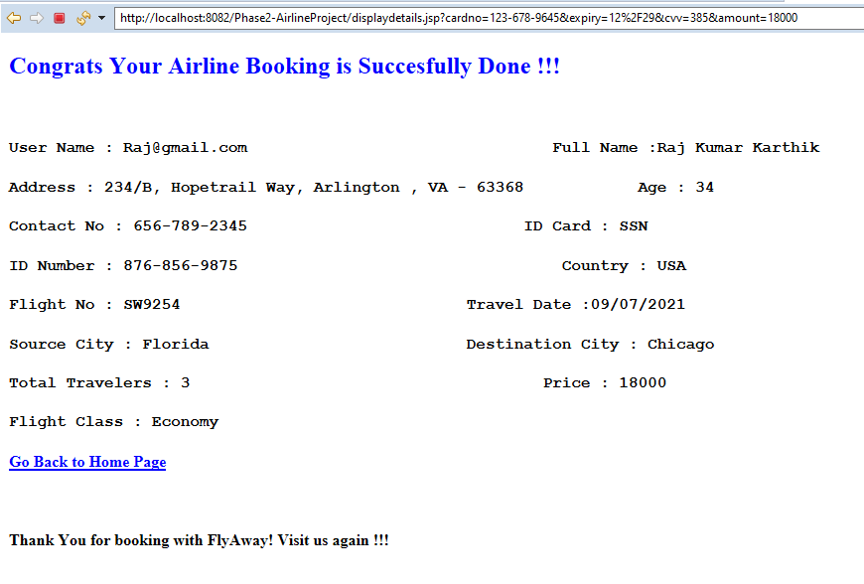

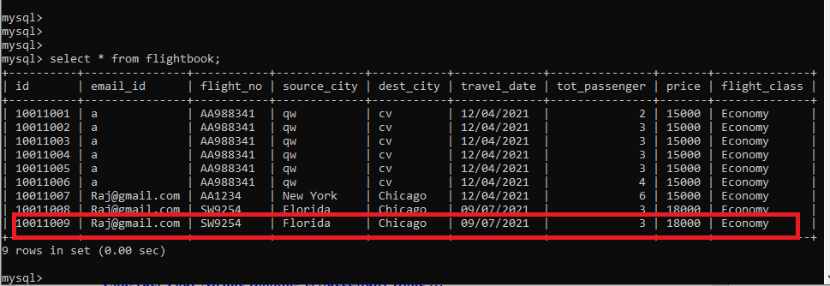

* Go back to welcome page,

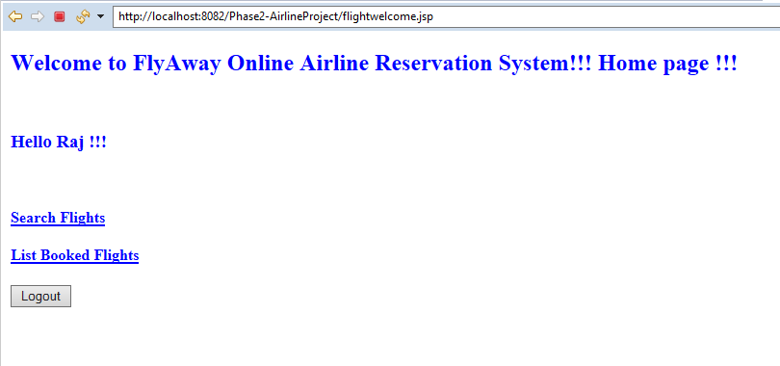

* List of booked file enquiry can be viewed by the user,

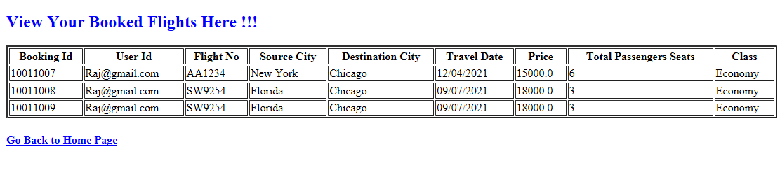

* Logout of the session,

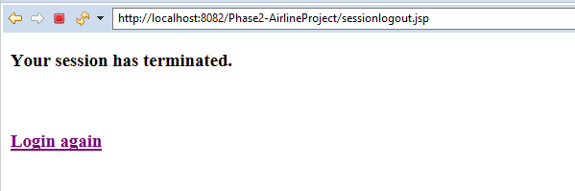

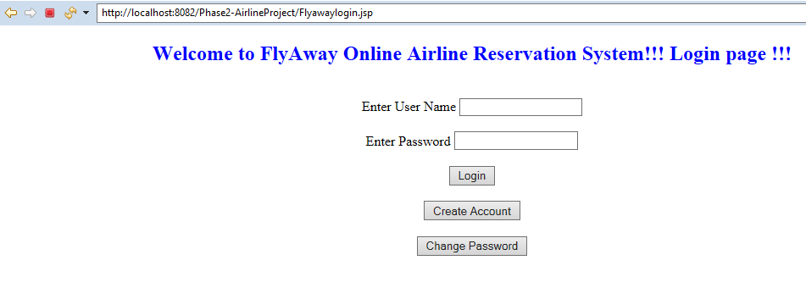



## **Pushing the code to GitHub repository**

* Open your command prompt and navigate to the folder where you have created your files.

**cd <folder path>**

* Initialize repository using the following command:

**git init**

* Add all the files to your git repository using the following command:

**git add .**

* Commit the changes using the following command:

**git commit -m <commit message>**

* Push the files to the folder you initially created using the following command:

**git push -u origin main**

**Source code for the project available under below repository,**

**https://github.com/S-KAVITHA/ Phase2-AirlineProject**